**Roadkill Reporter**

A Smartphone Application for Tracking Wildlife-Vehicle Collisions

**April**

**2011**





**Dr. John A. Bissonette**

**Daniel Olson, Ph.D. Student**

**Dr. Patricia Cramer**

**Megan Schwender, MS Student**

**USGS-Utah Cooperative Fish and Wildlife Research Unit**

**Utah State University, Logan 84322-5290**

[**john.bissonette@usu.edu**](mailto:john.bissonette@usu.edu)

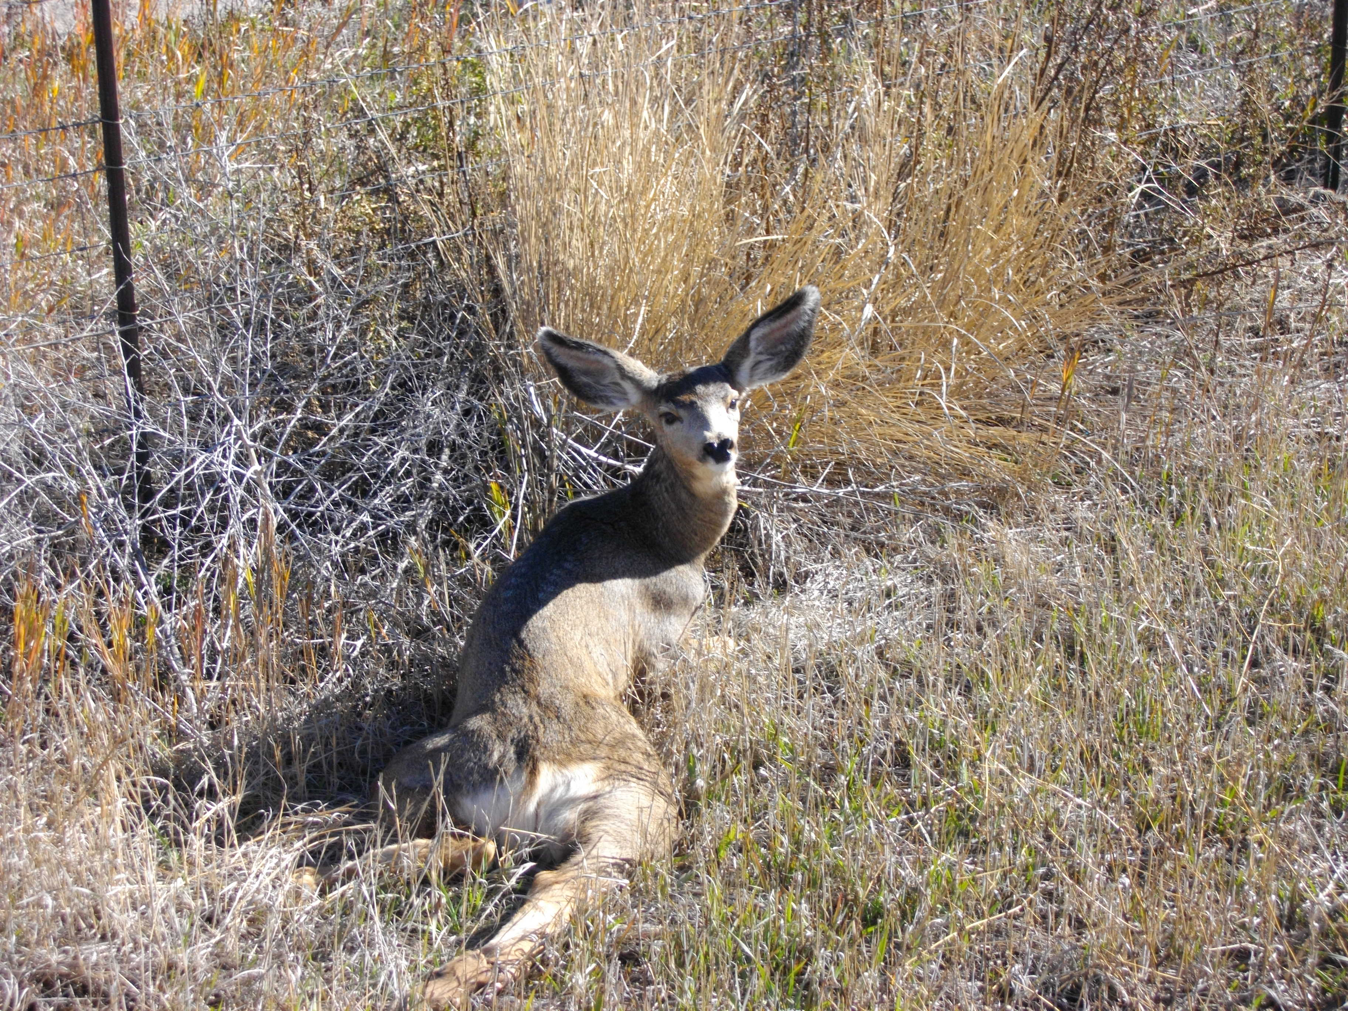



**Introduction**

Wildlife-vehicle collisions (WVCs) are a global problem that results in expensive property damage, human injuries, and usually the death of the animal involved (Forman and Alexandar 1998, Trombulak and Frissell 2000). In Utah from 1992-2005, the total costs associated with WVCs was 462 million (West 2006), and the majority of these collisions involved mule deer (*Odocoileus hemionus*). Because WVCs are a public safety hazard that can potentially impact wildlife populations, it is important to track the locations, numbers, and species involved. This, however, can be a daunting task because of the large number of animals that are killed annually and the extensive area over which they occur. As WVCs occur throughout the state, the problem transcends federal, state, and private management boundaries. Consequently, multiple agencies are involved in removing wildlife carcasses from roads and documenting their locations. These agencies need accurate, useable information about WVCs to effectively manage roads and monitor wildlife populations.

In Utah, wildlife carcass locations are currently documented using paper forms by both Utah Department of Transportation (UDOT) and Utah Division of Wildlife Resources (UDWR) personnel. Several steps are involved in this process. Initially technicians responsible for removing wildlife carcasses from roads record information on a paper form. They collect information on location (e.g. highway, mile marker, GPS coordinates), date, species, sex, and management region (Fig. 1). The information is then transferred from the paper form into a spreadsheet. Finally, the data is compiled from all UDWR management regions into one database. Mistakes that decrease the quality of the data occur when the technician records incorrect information or the person transcribing the data from the paper forms has difficulty reading the technician’s handwriting. Data entry errors are especially problematic when recording coordinate locations. For instance, technicians are recording coordinate locations that are string of numbers, such as: E 446328 N 4384359. If the N **4**384359 coordinate was entered incorrectly as N **3**384359, the location would be 1 million meters south of the actual location. Even though technicians and staff transcribing data are careful to avoid these errors, they do occur. Checking the accuracy of locations after they have been entered takes a substantial amount of time and incurs significant labor expenses.

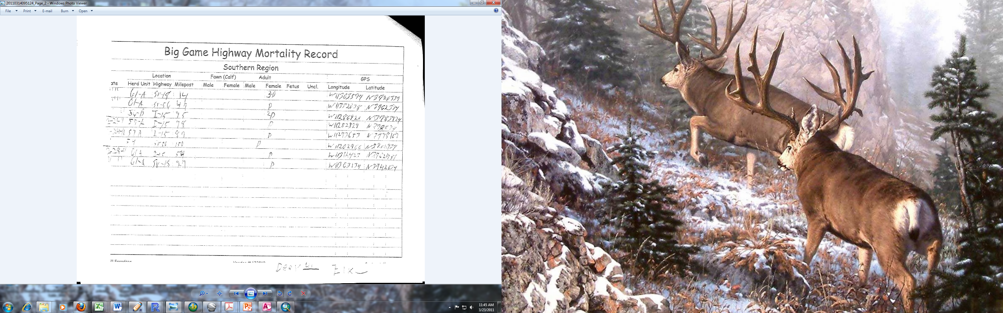

**Figure 1.** Example of a paper form submitted to the UDWR for entry into the statewide database

Advances in cellphones and mapping technology could be used to create a reporting system that 1) is inexpensive to develop and maintain, 2) is easy to use, 3) allows multiple users across the state to enter information into one database, 4) minimizes data entry errors, 5) reduces data entry time, and 6) provides a way to visualize carcass locations on highways throughout the state. We are proposing the creation of a reporting system that uses existing smartphone technology. Smartphones are cellphones that have the functionality of a computer, internet access, and GPS capabilities. Additionally, smartphones use software programs called applications (apps) that allow them to perform specialized tasks. In our reporting system, personnel responsible for removing wildlife carcasses from roads use a smartphone with a specialized application to enter information about wildlife carcasses. That information is then transferred to a centralized database and mapped for immediate viewing.

A reporting system such as this has many benefits. It increases efficiency of data collection by decreasing the time required for recording carcass information in the field. It increases data accuracy, because technicians will no longer record coordinates manually. Additionally, carcass data is standardized and errors associated with transcription are eliminated. Finally, the automated mapping function will make carcass data immediately useable for management purposes, even if the user has no experience with or access to a Geographic Information System (GIS).

In this proposal, we describe the components of the reporting system, how the reporting system will be tested, and how the system, once created, can be easily modified for other tasks that require reporting of location data (e.g. bird surveys, road maintenance).

**Reporting System Components**

The reporting system we described above has 3 major components: 1) a smartphone and application, 2) a website with a database, and 3) an automated mapping function (Fig. 2).

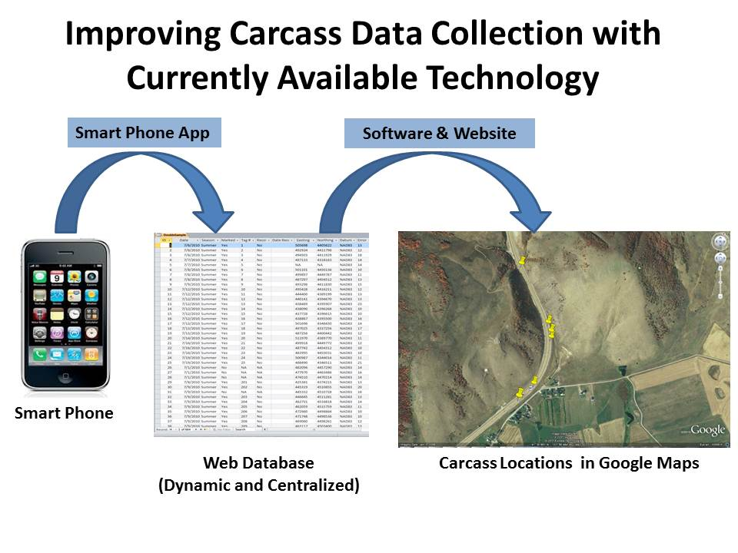

**Figure 2.** The three major components of the reporting system.

**1. Smart Phone and Application**

In 2010, >90% of the Americans used cellphones (CTIA 2011), and over a quarter of those phones were smartphones (ComScore 2011). Smartphones are becoming increasingly popular, because they combine a computer, internet access, digital camera, GPS, and cellphone into one handheld device. As a result, they are used for a wide array of applications, which now include environmental and wildlife monitoring. For example, smartphones applications have been developed to report air quality (Robotic Embedded Systems Laboratory 2011) and stream condition (IBM 2011). A recent smartphone application was created which allowed users to photographically document wildlife locations throughout the world (Project Noah 2011).

The smartphone application that we propose to track WVCs in Utah is “Roadkill Reporter”. The Roadkill Reporter app gives field technicians the ability to record information on wildlife carcasses electronically without using a paper form. The technician simply clicks on the Roadkill Reporter app and enters information into a report form on the smartphone screen (Fig. 3). The app automatically populates information on user ID, date, time, and extracts location coordinates from the smartphone GPS. This eliminates location and transcription errors. Furthermore, information on highway number, species, sex, and management region is entered through dropdown menus, thus minimizing entry errors and standardizing reported information. After the information has been entered, the technician simply pushes ‘send’ to transfer the data, via a mobile internet connection (3G), to an online database. We expect the whole process to take less than 1 minute per carcass. If the technician happens to be in an area without internet service, the entered data will be stored in the phone. When the phone has internet service again, it will automatically send accumulated locations to the database.

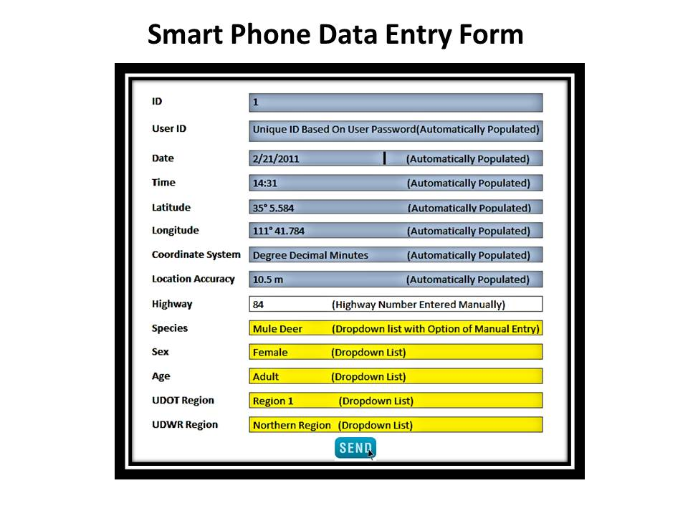

**Figure 3**. An example of what the report form will look like for the Roadkill Reporter app.

The Roadkill Reporter app will be created by Utah State University’s Programming and Design Team, which has experience developing smartphone applications. It will take approximately 6 weeks of work by the programming team to create the application. Additionally, the Roadkill Reporter app will be compatible with two of the most widely used smartphones: the Apple IPhone and the Google Android (Fig 4).

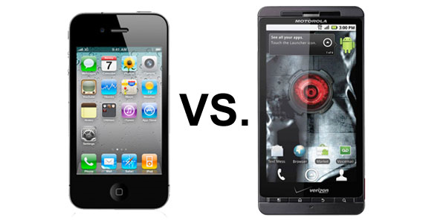

**Figure 4.** Apple IPhone (left) and Google Android (right)

**2. Website and Database**

The second component of the reporting system is a secure, online database with a website interface. The database will be setup to receive carcass locations from the Roadkill Reporter app. The website will function as a place to view wildlife carcass locations, to enter locations manually if needed, and to extract carcass location data for further analysis. Because several agencies require current WVC information, a website is an ideal way to share this data with whoever may need it. Viewing carcass data will be open to the public, however other features such as entering and modifying data will be password protected. The website and database may be hosted on a USU, UDWR, or a UDOT server. However, keeping the database and website on a UDWR or UDOT server would reduce the annual maintenance costs of the system (See Budget).

The website and database will also be constructed by the USU Programing and Design Team. It will take approximately 6 weeks for the design team to develop this component of the reporting system and the automated mapping function which is described below.

**3. Automated Mapping**

The third component of the reporting system is the automated mapping of carcass locations, which is incorporated into the website and synchronized with the database. Each time a technician transfers a carcass location to the online database, the location is automatically mapped on the reporting system website in Google Maps (fig. 5). Google Maps is an excellent visualization tool that allows carcass locations to be overlaid on a highway view or high resolution satellite imagery. People viewing carcass locations will have the option to choose the species and date range (e.g. week, month, year) they want to display. The automated mapping function will allow rapid assessment of problem areas, even for users that have little experience with GIS. If the user wishes to perform more quantitative analyses, the database can be extracted from the website and then imported into a GIS.

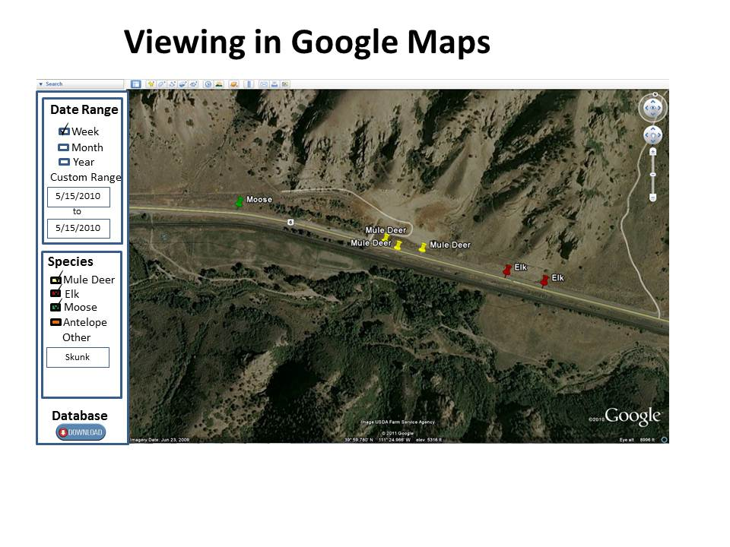

**Figure 5**. An example carcass locations mapped in Google Maps

**System Testing and Future Applications**

**Testing**

A “Proof of Concept” is necessary and involves field testing the accuracy of the reporting system, allowing us to smooth out system glitches. The reporting system will be field tested for 3 months using both an IPhone and Android phone. We will record carcass locations using the Roadkill Reporter app and a Garmin GPS to access location accuracy of the smartphone GPS. Additionally, we will record the time required to enter data using the Roadkill Reporter app. Because we are currently conducting a study on wildlife-vehicle collisions, field testing can be done for only the expense of the smartphones and the phone service. There will be no additional expenses for technician time or travel.

**Future Applications**

Once this system is developed to report wildlife carcasses, it is easy to see how it could be modified for any task that requires reporting of location data. For example, the system could be used to report road maintenance needs such as pot holes or broken guard rails. It also could be used to report bird locations during surveys that involve the public. Additionally, it could be an effective way for hunters to report harvest locations. There are a number of applications that this system could be used for, and it would only take minor programming changes to modify the carcass reporting system to other applications.

**Summary**

The wildlife reporting system that was described above will revolutionize the way wildlife carcass data are collected, reported, and used in Utah. It will improve data accuracy, increase efficiency, and make data highly usable for management purposes. Additionally, the source code for the system will be made freely available, so other states can follow Utah’s lead. Perhaps most importantly, it will result in much lower costs for activities that are now more expensive than they need to be.

**Deliverables:** The reporting system will be developed and delivered to the Utah Department of Transportation in 3 phases. Phase 1 is creation of the reporting system database and website with the incorporated mapping function. Phase 2 is the programming of the Roadkill Reporter smartphone application. Phase 3 is the field testing of the complete system. The project will be completed in its entirety by November 15, 2011.

**Literature Cited**

ComScore. 2010. U.S. Smartphone vs. Non-Smartphone Subscriber Share. <http://www. comscoredatamine.com/2010/12/u-s-smartphone-vs-non-smartphone-subscriber-share/>

CTIA. 2010. Semi-annual wireless industry survey results. <[http://files.ctia.org/pdf/CTIA__Survey_ Midyear_2010_Graphics.pdf](http://files.ctia.org/pdf/CTIA__Survey_%20Midyear_2010_Graphics.pdf)>

Forman, R. T. T. and L. E. Alexander. 1998. Roads and their major ecological effects. Annual Review of Ecology and Systematics 29:207-231

IBM. 2011. Creek watch <[http://www.ibm.com/smarterplanet/us/en/water_management/article/ creek_watch.html](http://www.ibm.com/smarterplanet/us/en/water_management/article/%20creek_watch.html)>

Project Noah. 2011. <<http://www.projectnoah.org/>>

Robotic Embedded Systems Laboratory. 2011. Air Visibility Monitoring. <http://robotics.usc.edu /~mobilesensing/Projects/AirVisibilityMonitoring>

Trombulak, S. C., and C. A. Frissel. 2000. Review of the ecological effects of roads on terrestrial and aquatic communities. Conservation Biology 14:18-30.

West, P. 2008. Wildlife and domestic animal toolkit. Utah Department of Transportation. Report. Pp.61

|  |  |  |  |
| --- | --- | --- | --- |
| **Estimated Project Budget** | | | |
| **One Time Costs** | **Hours** | **$/Hour** | **Price** |
| **Development: USU Programming and Design Team** |  |  |  |
| ***Programming*** |  |  |  |
| Smartphone Application | 180 | $55 | $9,900 |
| Website, Database , and Automated Mapping | 170 | $55 | $9,350 |
| Fixes and Minor Changes | 12 | $55 | $660 |
| Documentation & Training | 20 | $55 | $1,100 |
| ***Server Infrastructure*** |  |  |  |
| System Administration |  |  | $1,500 |
| CommVault Backup Agent |  |  | $450 |
| Virtual Server |  |  | $900 |
| Off Site Backup |  |  | $100 |
| **Field Testing: Utah Cooperative Fish and Wildlife Research Unit** |  |  |  |
| ***Salary and Wages*** |  |  |  |
| 2 technicians (20 hrs/wk *12 wks) | 480 | $0 | $0 |
| ***Equipment*** |  |  |  |
| 2 Smartphones (1 IPhone, 1 Android) |  |  | $1,300 |
| ***Services*** |  |  |  |
| Verizon Service (2 phones * 3 months * $80/month) |  |  | $480 |
|  | **Develop and Testing** | | **$25,740** |
|  | **Indirect Costs1 (10%)** | | **$2,574** |
|  | **Project Total** |  | **$28,314** |
|  |  |  |  |

1 Based on 10% indirect costs. If indirect costs are more, then that will increase the Project Total Costs